**Name : Atharv Jangam**

**Semester: Fall 23**

**Week 7 coding practice**

1. **Write a query to find documents with birth year = 1980**

Ans: Query

{

'birth year': 1980

}

**Output:**

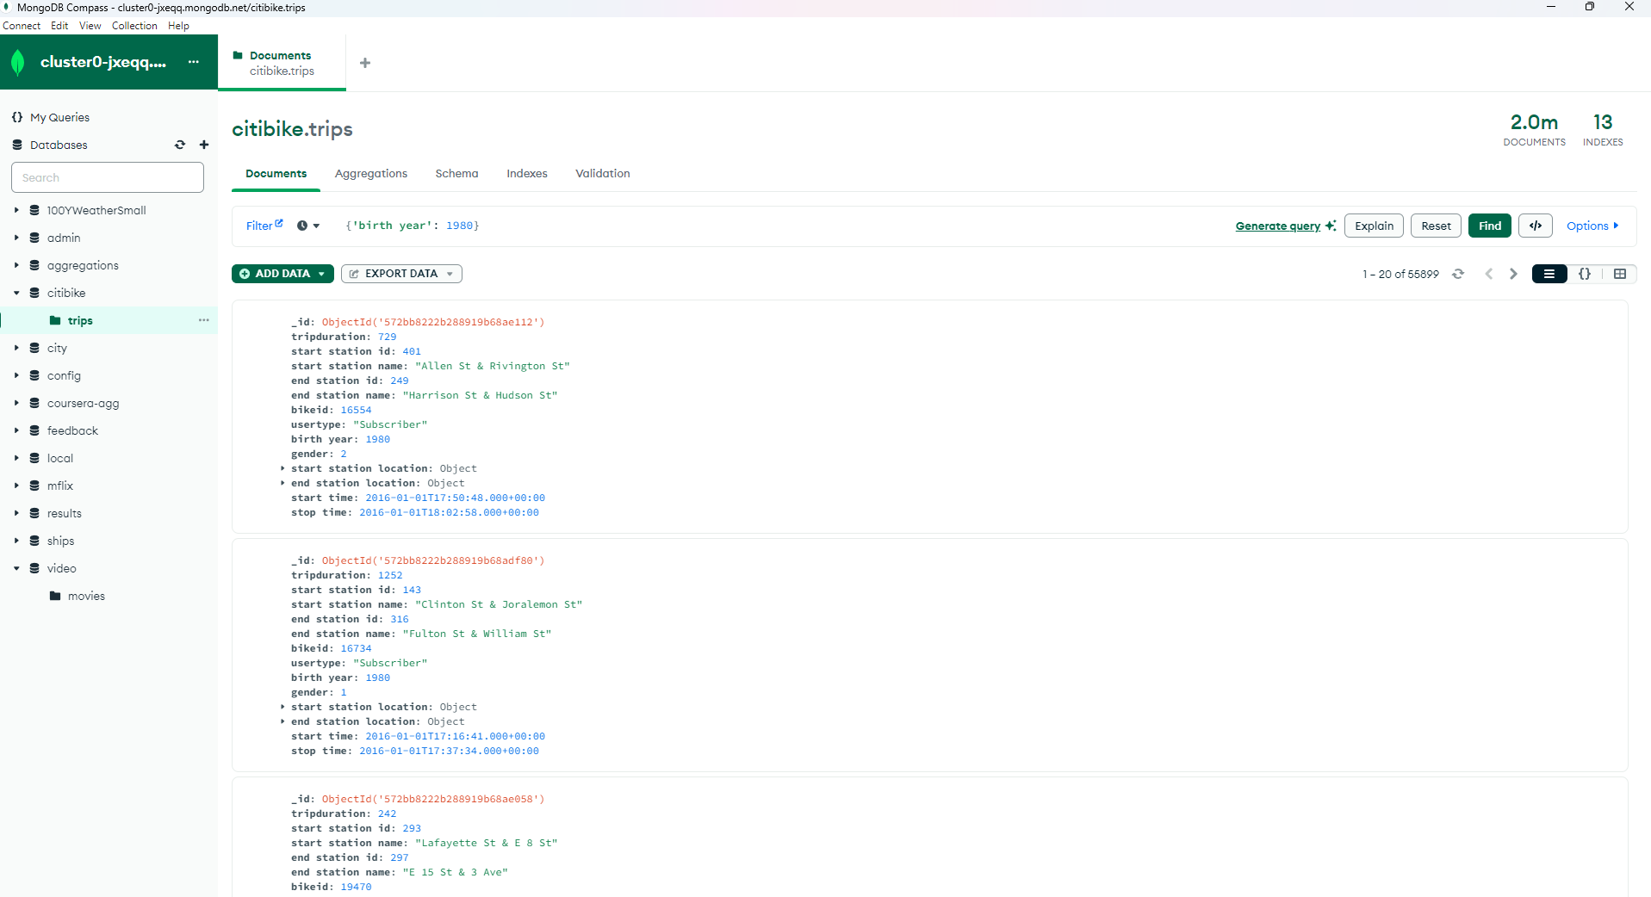

1. **Write a query to find documents with birth year greater than 1999**

Ans: Query

{

'birth year': {

$gt: 1999

}

}

**Output:**

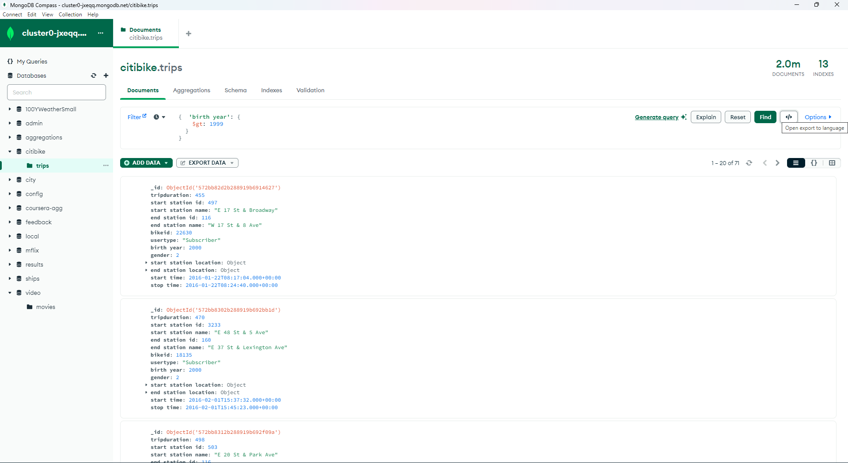

1. **Use the same query from #4 but limit to only 4 documents**

{

'birth year': {

$gt: 1999

}

}

**Output:**

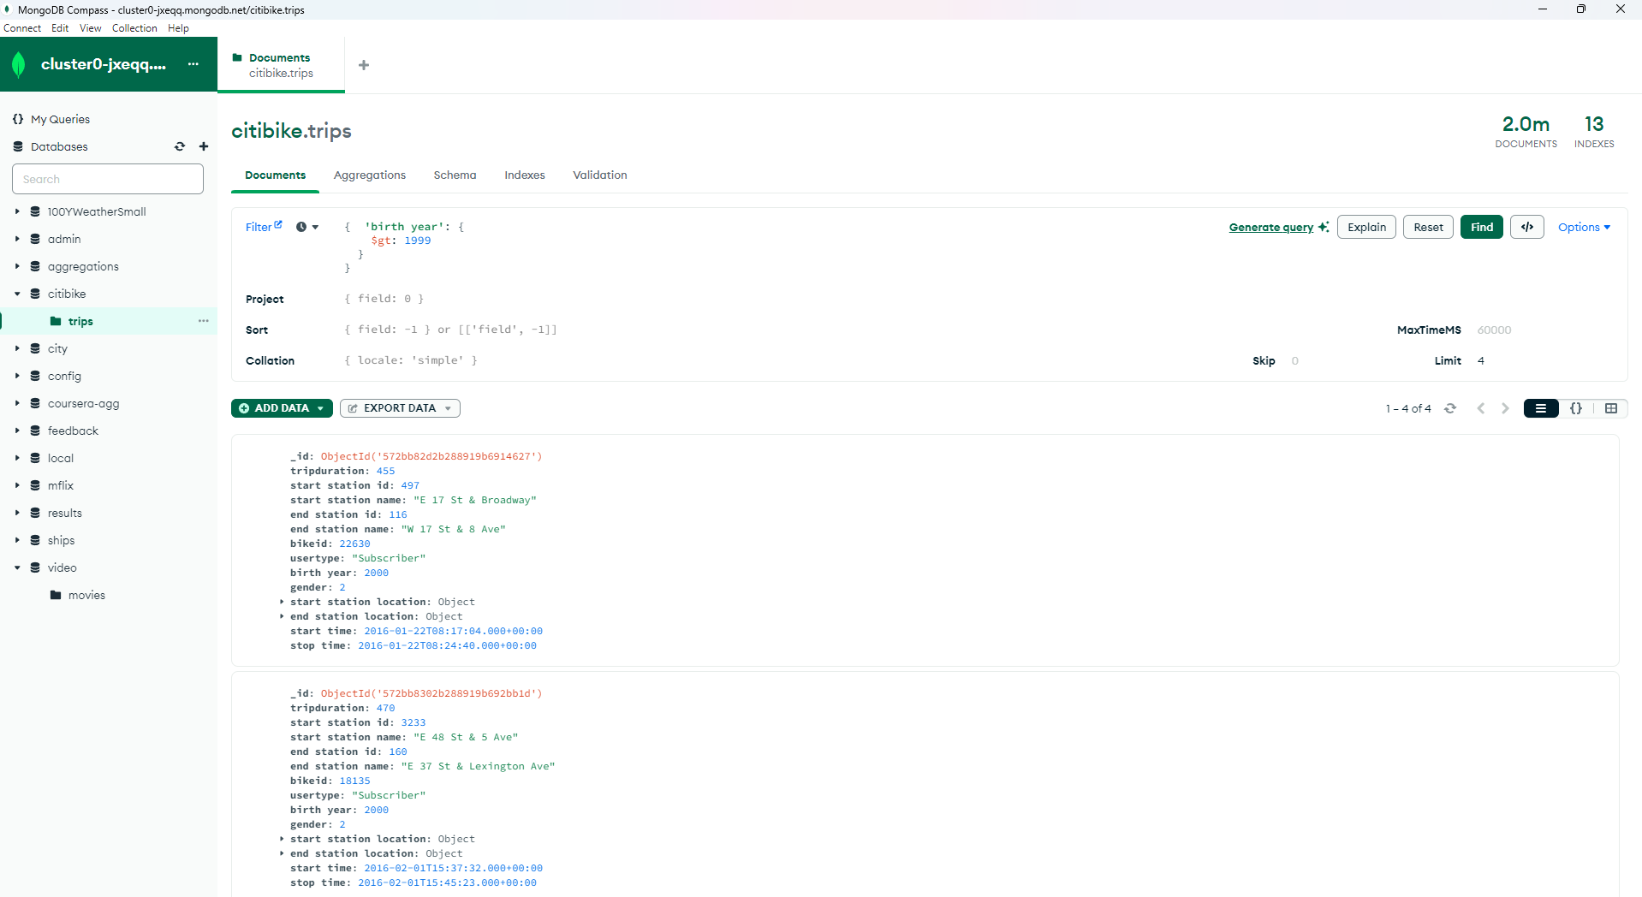

1. **Write a query to find documents with birth year > 1999 and < 2001. Keep 4 documents limit.**

{

'birth year': {

$gt: 1999,

$lt: 2001

}

}

**Output:**

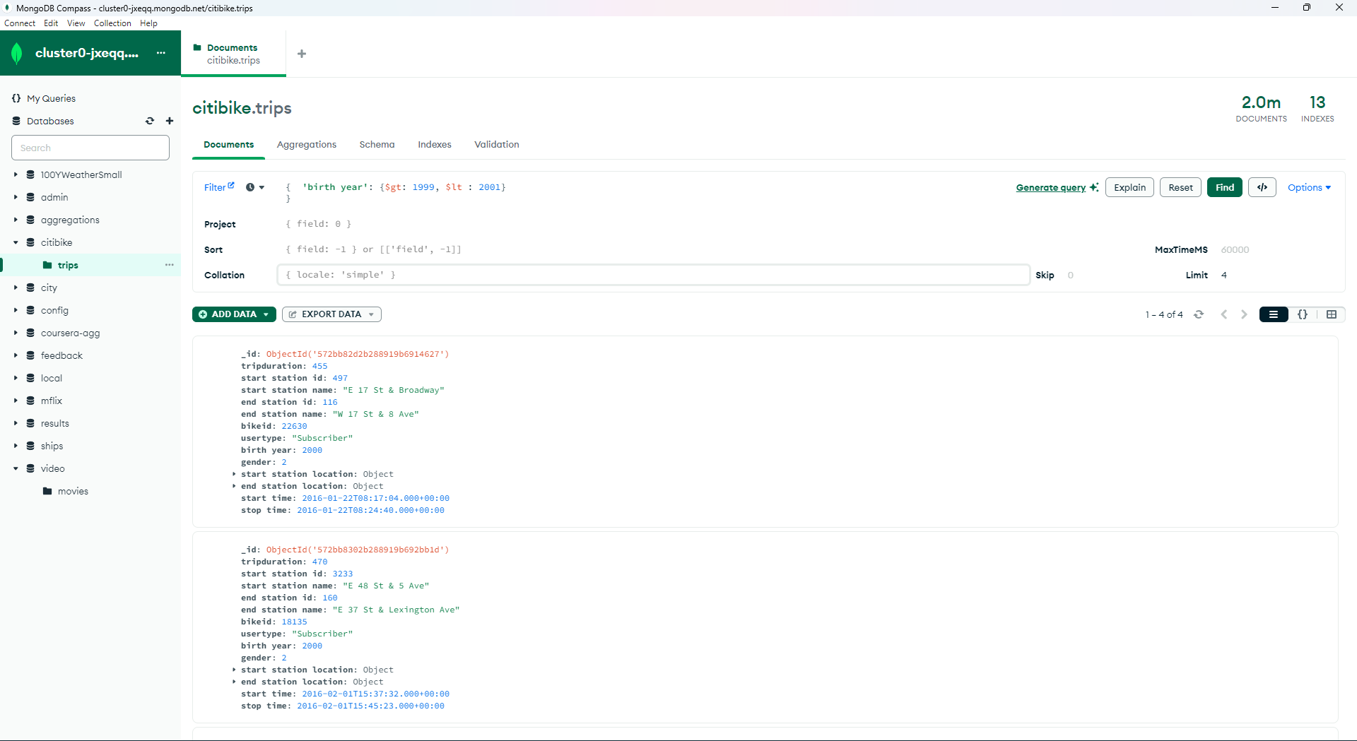

1. **Write a query to find documents with birth year greater or equal 1999**

{

'birth year': {

$gte: 1999

}

}

**Output:**

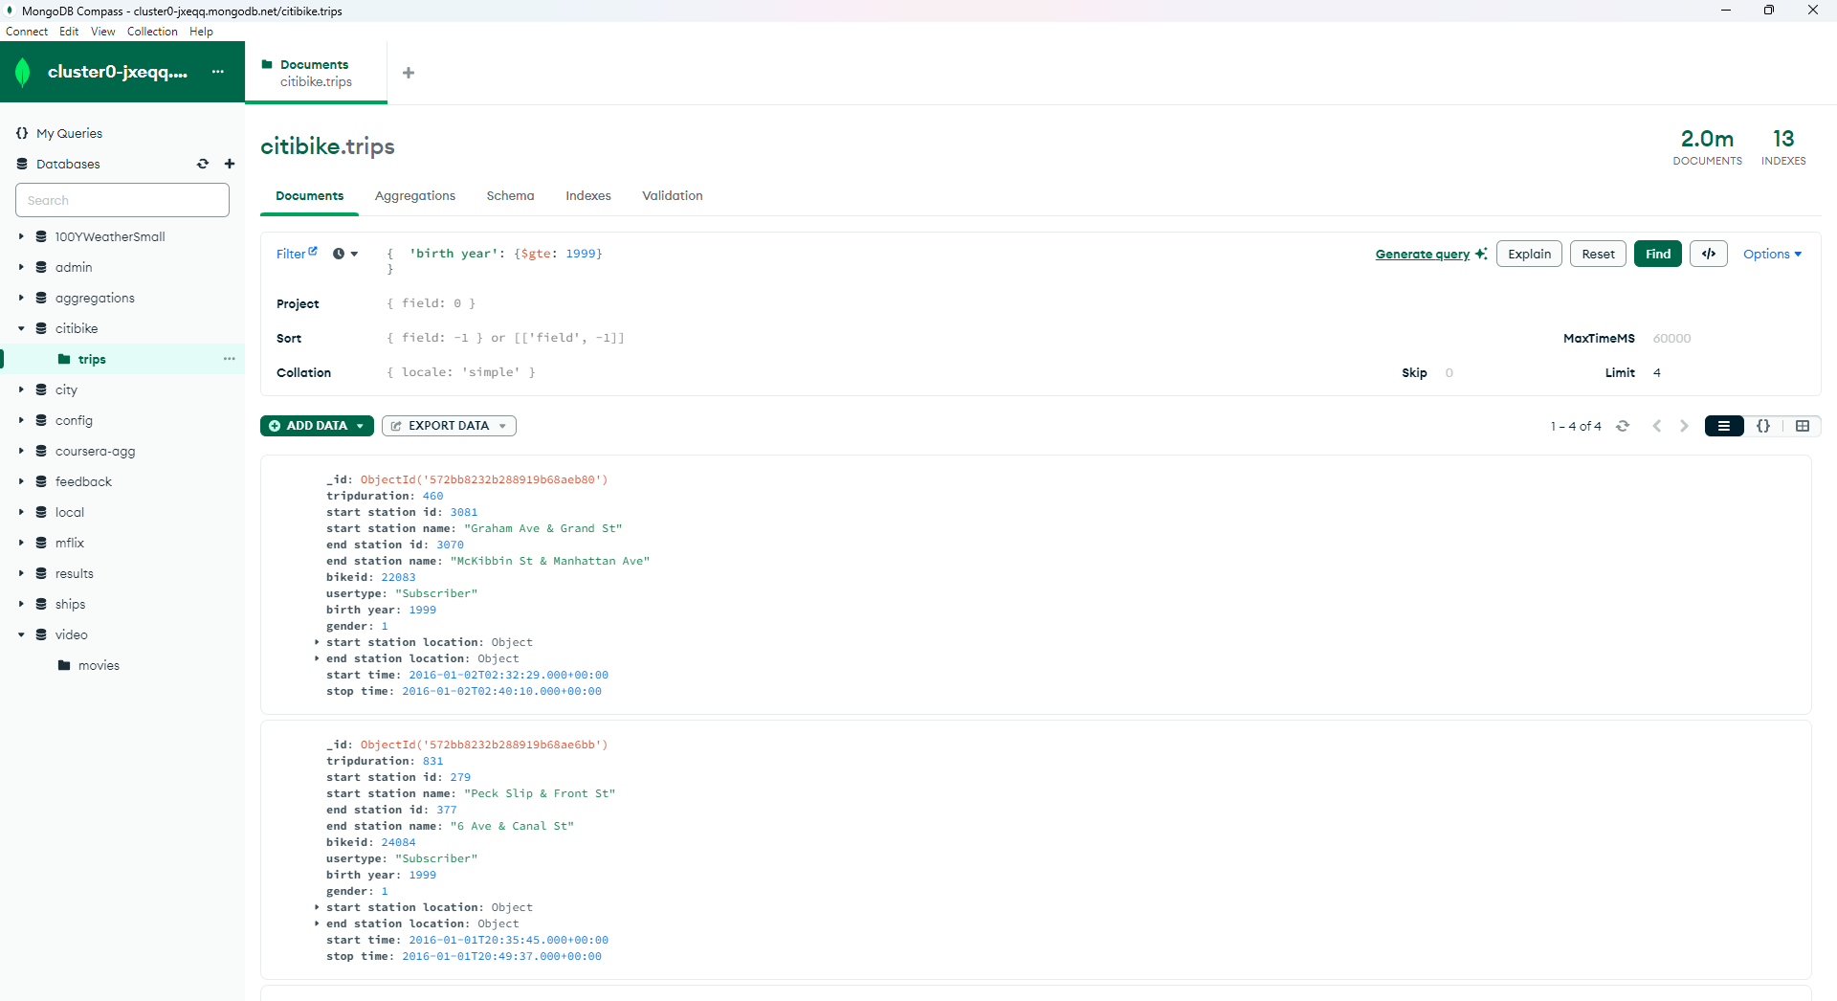

1. **Change to a database 100YWeatherSmall. The collection is called data. Notice you have wind Object (Document) with the following fields: direction, type, speed. Find documents with the wind type = "C" [Calm]**

{

"wind.type": "C"

}

**Output:**

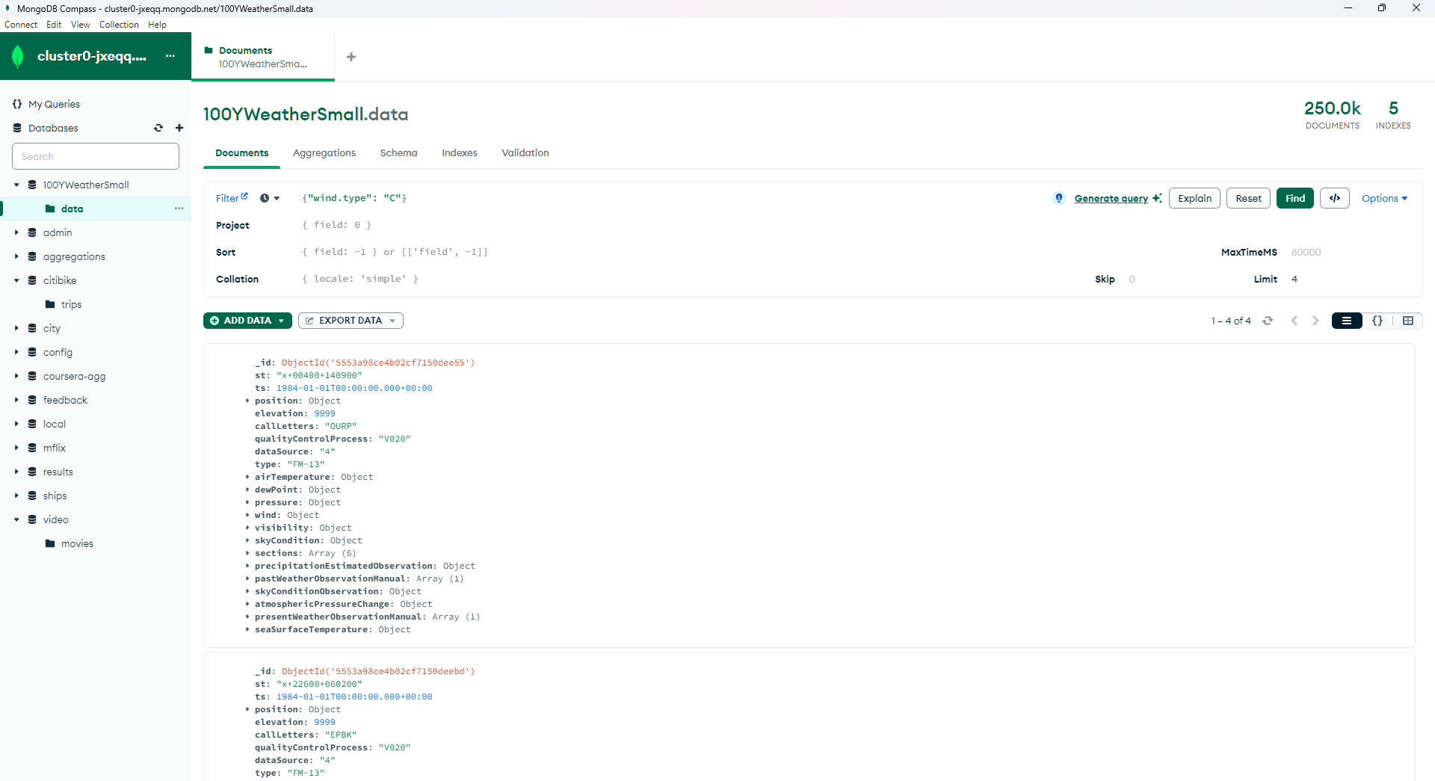

1. **In the 100YWeatherSmall database wind has a document direction with the fields: angle and quality. Find documents with the wind quality = "1"**

{

"wind.direction.quality": "1"

}

**Output:**

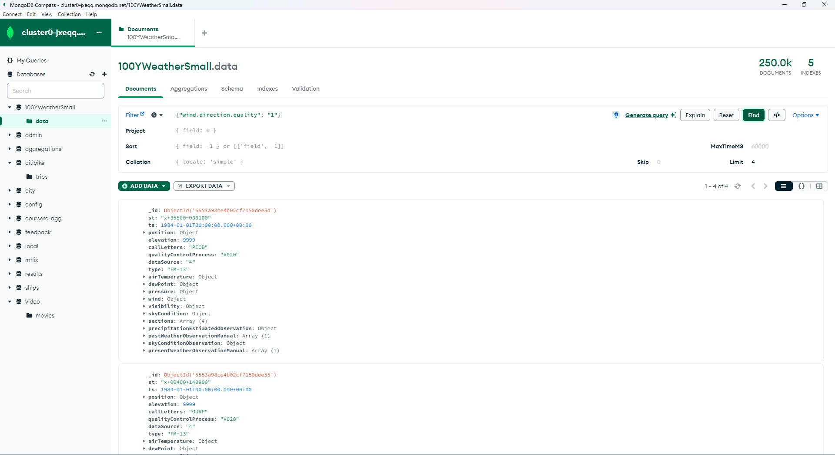

**9) Switch to video database movies. Find movies with runtime > 90 and viewerRating > 7. Project only titles and runtime**

{

"runtime": {

$gt: 90

},

"viewerRating": {

$gt: 7

}

}

**Output:**  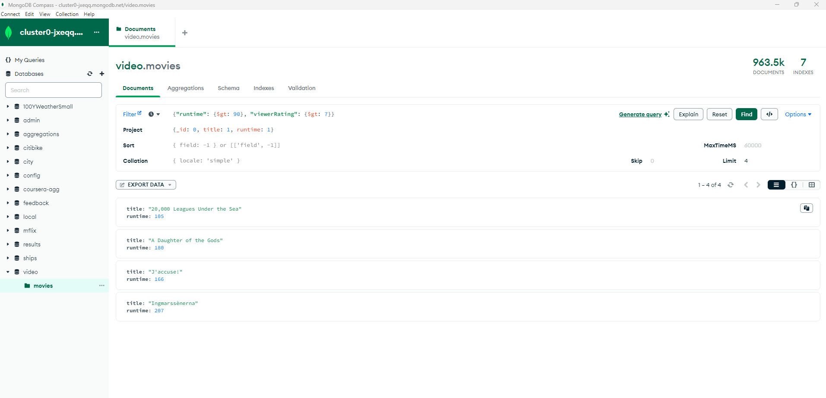

**10) video database movies. Find movies with genre that is not empty "". Project only titles and genre. Limit to 4 movies.**

{

"genre": {

$ne: ""

}

}

**Output:**

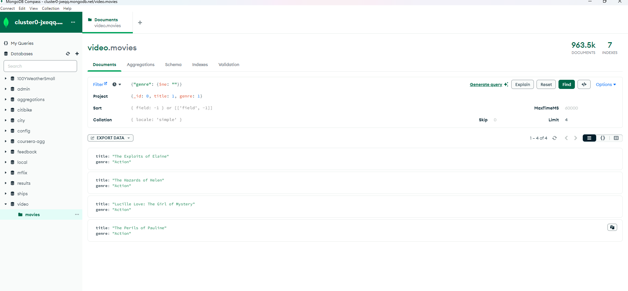

**11) video database movies. Find movies with genre that is Short or Drama. Project only titles and genre. Limit to 4 movies**

{

genre: {

$in: ['Short', 'Drama']

}

}

**Output:**

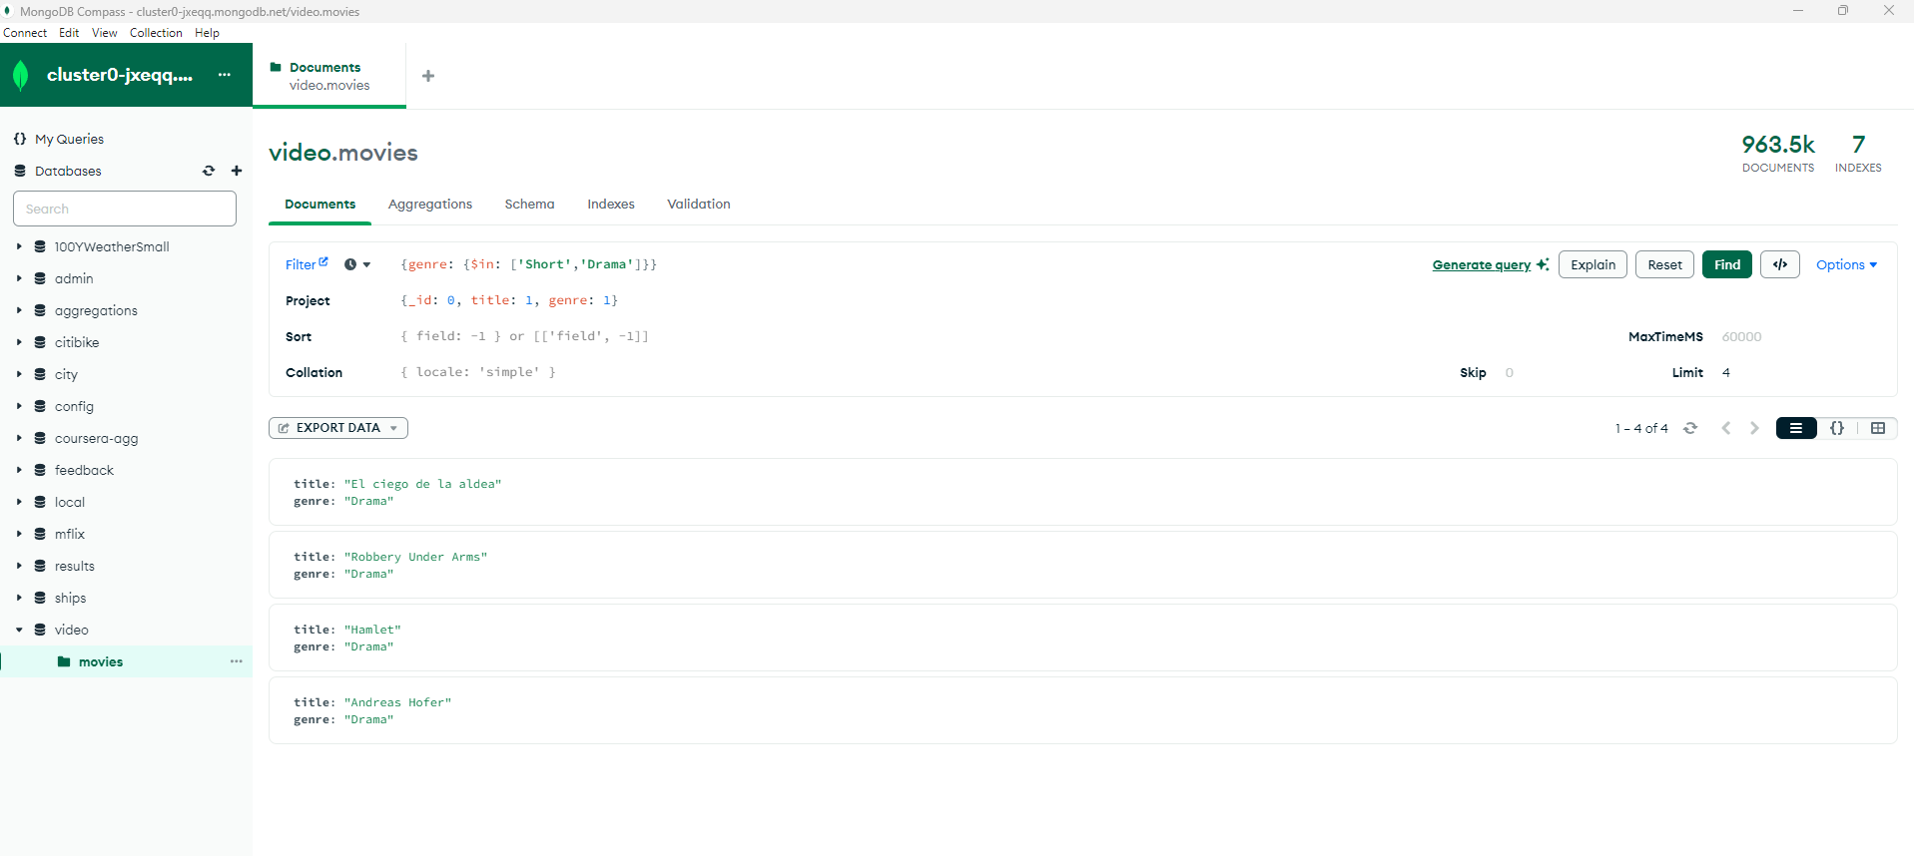

**12) video database movies. Find movies where language field exists.**

{

language: {

$exists: true

}

}

**Output:**

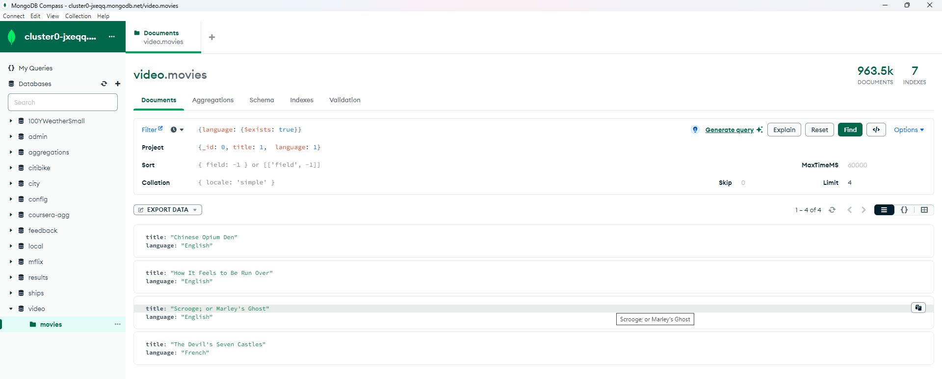

**Part 2:**

